Practical 3: Implement private cloud with Xen server.
Implementing a bare-metal (Type-1) hypervisor like Xen on a Windows 11 desktop requires a specific approach. Because Xen is designed to be installed directly on the hardware (replacing the host operating system), we must use Nested Virtualization.
We will use Oracle VM VirtualBox to create a virtual machine that acts as our bare-metal server, and then install Xen inside it. The most accessible and fully-featured open-source version of XenServer currently available is XCP-ng.

Phase 1: Downloads & Prerequisites
- Update VirtualBox: Ensure you have the latest version of Oracle VM VirtualBox installed on your Windows PC.
- Download XCP-ng (The Xen Server):
  - Go to the XCP-ng download page.
  - Download the latest ISO file (e.g., XCP-ng 8.2 LTS).

Phase 2: Configure VirtualBox for Nested Virtualization
If nested virtualization is not enabled, Xen will not be able to host its own virtual machines.
- Open VirtualBox and click New to create a virtual machine.
- Name and Operating System:
  - Name: Xen_Private_Cloud
  - Type: Linux
  - Version: Other Linux (64-bit)
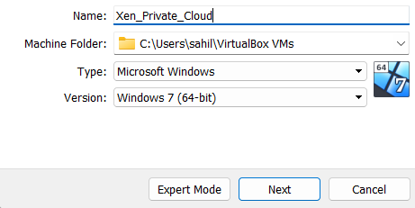
- Hardware:
  - Base Memory (RAM): Allocate at least 4096 MB (4 GB).
  - Processors: Allocate at least 2 CPUs.
  - Crucial Step: Check the box that says "Enable Nested VT-x/AMD-V". (If this is greyed out, you may need to enable it via Windows Command Prompt: VBoxManage modifyvm "Xen_Private_Cloud" --nested-hw-virt on).
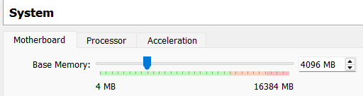
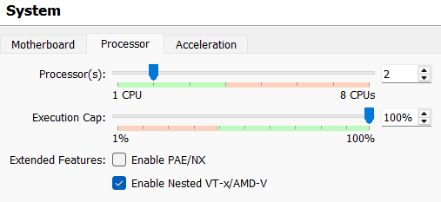
- Hard Disk: Create a Virtual Hard Disk of at least 30 GB (dynamically allocated).
  - Go to Settings → Storage → on Controller: IDE click on add hard disk.
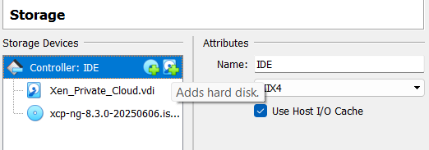
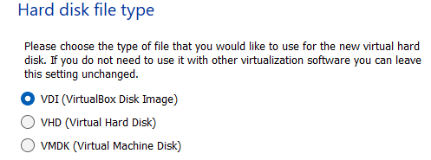
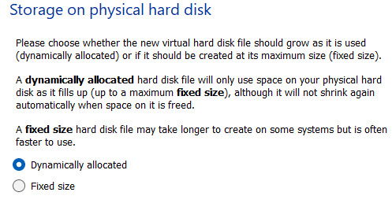
- Set to 30 GB, then click on choose Xen_Priivate_Cloud.vdi file and click ok.
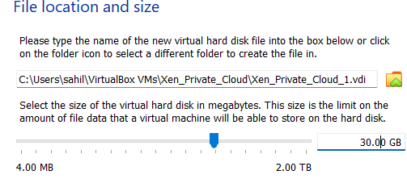

- It should look like the image below. Then click on ok.
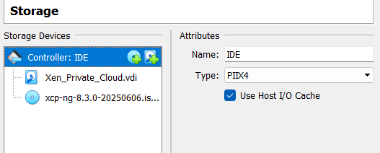

- Network Settings:
  - Select your new VM and click Settings →Network.
  - Change "Attached to" from NAT to Bridged Adapter. This allows your Xen server to get an IP address from your local physical router.
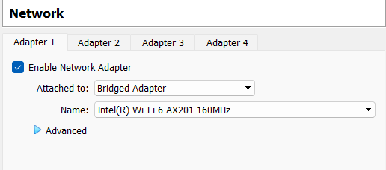
- Storage Settings:
  - Go to Settings →Storage.
  - Click on the empty CD icon under the IDE Controller.
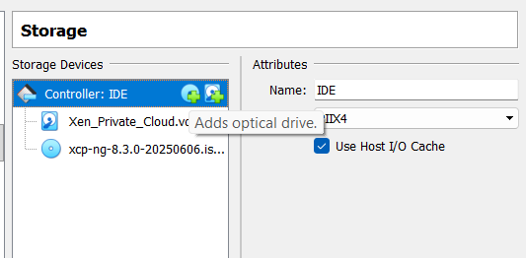
  - Click the disk icon on the right and select "Choose a disk file...".
  - Select the XCP-ng ISO file you downloaded.
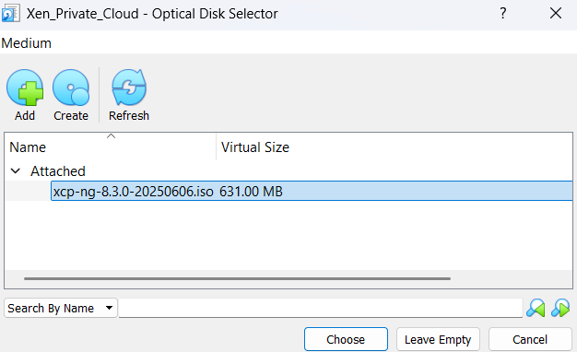

Phase 3: Install Xen Server (XCP-ng)
- Start the Xen_Private_Cloud virtual machine in VirtualBox.
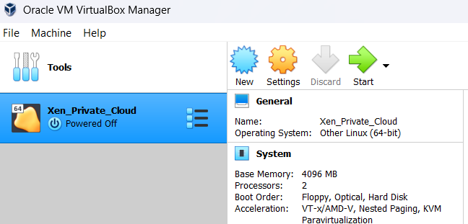
- The machine will boot into the XCP-ng installer (a blue text-based screen). Press Enter to begin.
- Keyboard Layout: Select [qwerty] us.
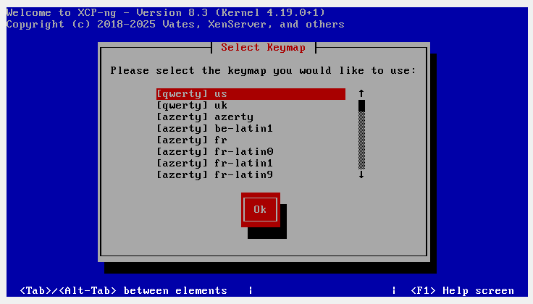
- Welcome to XCP-ng: Press Ok.
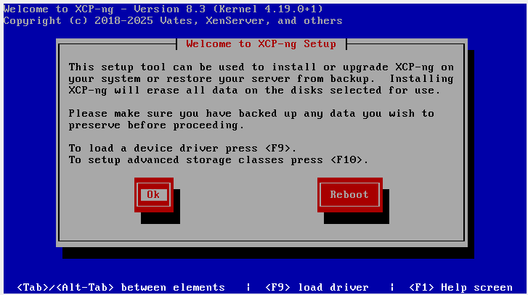
- EULA: Accept the End User License Agreement.
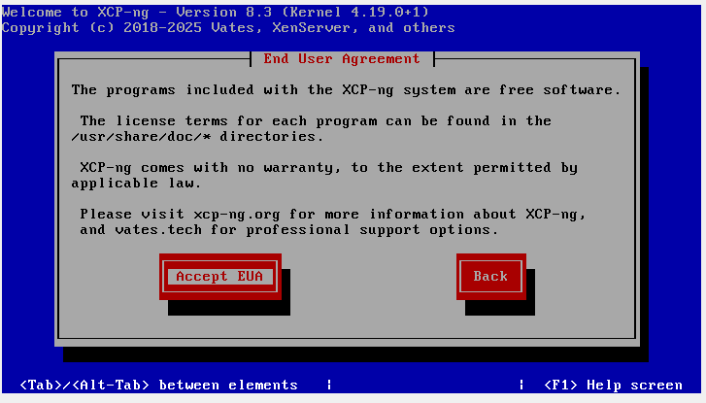
- Virtual Machine Storage: It will ask where to install. Select the 30 GB virtual hard disk we created (usually named sda). Choose Ext for the local storage type.
- Installation Source: Select Local media.
- Root Password: Create a strong password. Write this down; it is the master administrative password for your private cloud.
- Network Setup: * Select your management interface (usually eth0).
  - Choose DHCP (so your home router automatically assigns it an IP address).
- Hostname and DNS: Choose Automatically set via DHCP.
- Timezone: Select Asia →Kolkata.
- Install XCP-ng: Confirm and begin the installation. It will take a few minutes.
- Once finished, it will prompt you to remove the installation media. Go to VirtualBox menu: Devices →Optical Drives →Remove disk from virtual drive.
- Press Enter to reboot.

Phase 4: Access and Manage the Private Cloud
After the Xen VM reboots, it will sit at a black and blue console screen.
- Look at the console screen. It will display a line that says:
"Management Server IP: 192.168.x.x" (Your specific IP will be different).
- Open a standard web browser (Chrome/Edge) on your host Windows 11 PC.
- Type that IP address into the address bar (e.g., https://192.168.1.15).
- You will see a welcome page. From here, you have two ways to manage your new private cloud:
  - XCP-ng Center: A Windows desktop application you can download directly from that welcome page to manage your servers.
  - Xen Orchestra (XO): A web-based management interface. You can deploy a lightweight virtual appliance of XO directly from the Xen console screen using the "Quick Deploy" option.
Once logged into your management interface (using the username root and the password you created in Phase 3), you have successfully deployed a Type-1 private cloud hypervisor. You can now use this interface to allocate RAM, CPU, and storage to create entirely new virtual machines inside the Xen environment.

